Marathwada Shikshan Prasarak Mandal’s

**Deogiri Institute of Engineering and Management Studies,**

**Aurangabad**

**Seminar Report**

**On**

**Car Detection**

Submitted By

**Rutuja Sable (36126)**

**Manisha Wadekar (36127)**

**Satyan Joshi(36130)**

**Dr. Babasaheb Ambedkar Technological University**

**Lonere (M.S.)**



Department of Computer Science and Engineering

**Deogiri Institute of Engineering and Management Studies,**

**Aurangabad**

(2019- 2020)

**Seminar Report**

**On**

**Car Detection**

Submitted By

**Rutuja Sable (36126)**

**Manisha Wadekar(36127)**

**Satyan Joshi(36130)**

**In partial fulfillment of**

**Bachelor of Technology**

**(Computer Science & Engineering)**

Guided By

**Mr .Pankaj Durole**

Department of Computer Science & Engineering

**Deogirie Institute of Engineering and Management Studies,**

**Aurangabad**

**CERTIFICATE**

This is to certify that, the Seminar entitled “**Car Detection**” submitted by **Rutuja Sable, Manisha Wadekar, Satyan Joshi** is a bonafide work completed under my supervision and guidance in partial fulfillment for award of Bachelor of Technology (Computer Science and Engineering) Degree of Dr. Babasaheb Ambedkar Technological University, Lonere.

Place: Aurangabad

Date:

**Mr . Pankaj Durole Mr. S.B. Kalyankar**

**Guide Head**

**Dr. Ulhas D. Shiurkar**

**Director,**

**Deogiri Institute of Engineering and Management Studies**

**Aurangabad**

**Abstract**

Traffic management and information systems need

to obtain information about traffic with various sensors to

control the traffic flow properly. In this context, videos are very

actively used in traffic surveillance and control in recent years.

With the help of image processing based video surveillance

system in traffic management systems, many studies are done.

Processing of videos from traffic surveillance cameras is an

example of such applications, in which video is processed for

early warning or extracting information through some real time

analysis by means of detection and classification of vehicles. In

this paper, we present concise review on vehicle detection and

type classification

Traffic management and information systems need

to obtain information about traffic with various sensors to

control the traffic flow properly. In this context, videos are very

actively used in traffic surveillance and control in recent years.

With the help of image processing based video surveillance

system in traffic management systems, many studies are done.

Processing of videos from traffic surveillance cameras is an

example of such applications, in which video is processed for

early warning or extracting information through some real time

analysis by means of detection and classification of vehicles. In

this paper, we present concise review on vehicle detection and

type classification

Traffic management and information systems need

to obtain information about traffic with various sensors to

control the traffic flow properly. In this context, videos are very

actively used in traffic surveillance and control in recent years.

With the help of image processing based video surveillance

system in traffic management systems, many studies are done.

Processing of videos from traffic surveillance cameras is an

example of such applications, in which video is processed for

early warning or extracting information through some real time

analysis by means of detection and classification of vehicles. In

this paper, we present concise review on vehicle detection and

type classification

Traffic management and information systems need

to obtain information about traffic with various sensors to

control the traffic flow properly. In this context, videos are very

actively used in traffic surveillance and control in recent years.

With the help of image processing based video surveillance

system in traffic management systems, many studies are done.

Processing of videos from traffic surveillance cameras is an

example of such applications, in which video is processed for

early warning or extracting information through some real time

analysis by means of detection and classification of vehicles. In

this paper, we present concise review on vehicle detection and

type classification

Traffic management and information systems need

to obtain information about traffic with various sensors to

control the traffic flow properly. In this context, videos are very

actively used in traffic surveillance and control in recent years.

With the help of image processing based video surveillance

system in traffic management systems, many studies are done.

Processing of videos from traffic surveillance cameras is an

example of such applications, in which video is processed for

early warning or extracting information through some real time

analysis by means of detection and classification of vehicles. In

this paper, we present concise review on vehicle detection and

type classification

Traffic management and information systems need to obtain information about traffic with various sensors to control the traffic flow properly. In this context, videos are very actively used in traffic surveillance and control in recent years. With the help of image processing based video surveillance system in traffic management systems, many studies are done. Processing of videos from traffic surveillance cameras is an example of such applications, in which video is processed for early warning or extracting information through some real time analysis by means of detection and classification of vehicles. In this paper, we present concise review on vehicle detection and type **classification Video surveillance system is the most important dimension nowadays in order to maintain security and keep a track of events. It** is used as a security system because it has the power to track and detect objects of interest. The importance of video surveillance system lies in the reality that it can be used in static and dynamic background as well. Static or stationary background examples are shopping mall, bank, school, colleges, ATMs etc and dynamic refers to vehicle tracking systems and traffic related areas. The most basic video surveillance systems undergoes many phases , after which it is able to detect the object of interest and makes necessary action like triggering of alarms .In this paper study of various phases of VSS is made and for each phase various alternative solutions with their advantages and disadvantages have been discussed.

**Literature Survey**

Given an input of a video sequence taken from a moving car, vision system outputs an online description of road parameters, and locations and sizes of other vehicles in the images. This description is then used to estimate the positions of the vehicles in the environment and their distances from the camera-assisted car. The vision system contains four main components: the car detector, road detector, tracker, and process coordinator . Once the car detector recognizes a potential car in an image, the process coordinator creates a tracking process for each potential car and provides the tracker with information about the size and location of the potential car. For each tracking process, the tracker analyzes the history of the tracked areas in the previous image frames and determines how likely it is that the area in the current image contains a car. If it contains a car with high probability, the tracker outputs the location and size of the hypothesized car in the image. If the tracked image area contains a car with very low probability, the process terminates. This dynamic creation and termination of tracking processes optimizes the amount of computational resources spent.

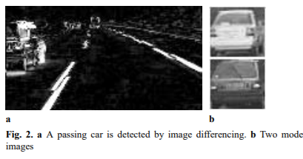

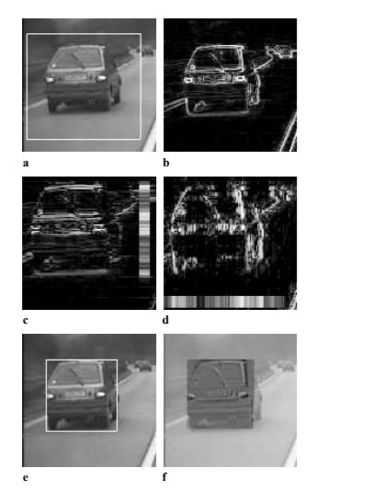

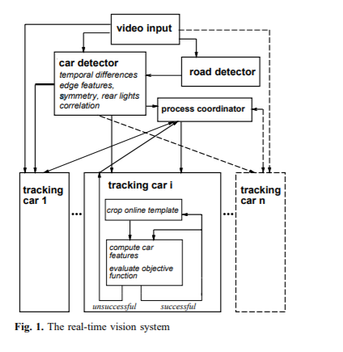

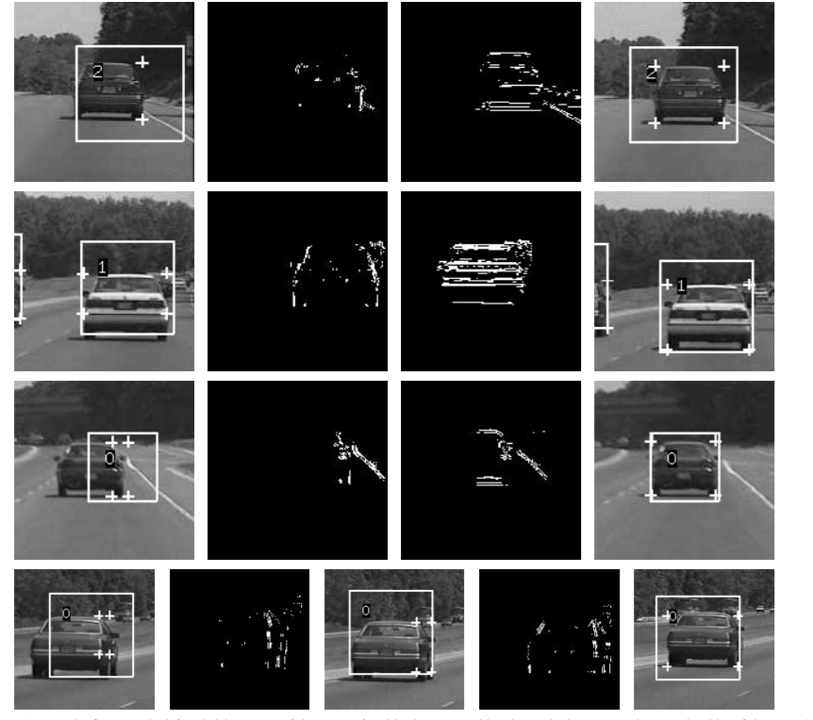

In the first row, the left and right corners of the car are found in the same position due to the low contrast between the sides of the car and background (first image). The vertical edge map resulting from this low contrast is shown in the second image. Significant horizontal edges (the horizontal edge map is shown in third image) are found to the left of the corners and the window is shifted to the left (fourth image). In the second row, the window shift compensates for a 10-pixel downward motion of the camera due to uneven pavement. In the third row, the car passed underneath a bridge, and the tracking process is slowly “recovering.” The tracking window no longer contains the whole car, and its vertical edge map is therefore incomplete (second image). However, significant horizontal edges (third image) are found to the left of the corners and the window is shifted to the left. In the last row, a passing car is tracked incompletely. First its bottom corners are adjusted, then its left side

V

EHICLE

T

YPE

C

LASSIFIC ATION

Classification is the method of finding which class a new

observed data belongs to according to the information

obtained from training set of the data which category class is

known. We can divide the machine learning-based

classification method into three steps: First to extract the

features to be used in classification, secondly to select the

classification algorithm to be used, and finally to test the

model. Table 2 gives some information on some researches

carried out on this subject

V

EHICLE

T

YPE

C

LASSIFIC ATION

Classification is the method of finding which class a new

observed data belongs to according to the information

obtained from training set of the data which category class is

known. We can divide the machine learning-based

classification method into three steps: First to extract the

features to be used in classification, secondly to select the

classification algorithm to be used, and finally to test the

model. Table 2 gives some information on some researches

carried out on this subject

V

EHICLE

T

YPE

C

LASSIFIC ATION

Classification is the method of finding which class a new

observed data belongs to according to the information

obtained from training set of the data which category class is

known. We can divide the machine learning-based

classification method into three steps: First to extract the

features to be used in classification, secondly to select the

classification algorithm to be used, and finally to test the

model. Table 2 gives some information on some researches

carried out on this subject

V

EHICLE

T

YPE

C

LASSIFIC ATION

Classification is the method of finding which class a new

observed data belongs to according to the information

obtained from training set of the data which category class is

known. We can divide the machine learning-based

classification method into three steps: First to extract the

features to be used in classification, secondly to select the

classification algorithm to be used, and finally to test the

model. Table 2 gives some information on some researches

carried out on this subject

**b)VEHICLE TYPE CLASSIFICATION**

Classification is the method of finding which class a new observed data belongs to according to the information obtained from training set of the data which category class is known. We can divide the machine learning-based classification method into three steps: First to extract the features to be used in classification, secondly to select the classification algorithm to be used, and finally to test the model. Table 2 gives some information on some researches carried out on this subject

**Goals**

The ultimate goal of our vision system is to provide a car control system with a sufficient analysis of its changing environment, so that it can react to a dangerous situation immediately. Whenever a physical system like a car control system depends on complicated computations, as are carried out by our vision system, the timing constraints on these computations become important. A “hard real-time system” guarantees – prior to any execution – that the system will react in a timely manner. In order to provide such a guarantee, a hard real-time system analyzes the timing and resource requirements of each computation task.

V

EHICLE

T

YPE

C

LASSIFIC ATION

Classification is the method of finding which class a new

observed data belongs to according to the information

obtained from training set of the data which category class is

known. We can divide the machine learning-based

classification method into three steps: First to extract the

features to be used in classification, secondly to select the

classification algorithm to be used, and finally to test the

model. Table 2 gives some information on some researches

carried out on this subject

V

EHICLE

T

YPE

C

LASSIFIC ATION

Classification is the method of finding which class a new

observed data belongs to according to the information

obtained from training set of the data which category class is

known. We can divide the machine learning-based

classification method into three steps: First to extract the

features to be used in classification, secondly to select the

classification algorithm to be used, and finally to test the

model. Table 2 gives some information on some researches

carried out on this subject